Zhengzhou University of Industrial Technology

DATABASE CURRICULUM DESIGN MANUAL

PROJECT： STUDENT MANAGEMENT SYSTEM

NAME： Joakim Bongani Munyanyi (Kong Jie)
MAJOR： Computer Science
STUDENT NUMBER： GX 17206
INSTRUCTOR： OU QUN YONG
TIME：2018/12/4_______________________ 2018/12/27
Zhengzhou University of Industrial Technology
DATABASE CURRICULUM DESIGN MANUAL

Project: Student Management System
Major: Computer Science and technology
Student Number : GX 17206
Name : Joakim Bongani Munyanyi (Kong Jie)

Main content:

Complete the design of the Student Management System database, first obtain the user requirements, then turn them into effective database design, and then transform the design into a practical, data consistency and integrity, data security database.

Basic requirements:

• Create an entity-relationship (E-R model) diagram for the Student Management System database
• Construct a simple and basic database design
• Capable of inserting records into the database and modify the data records
• Use and test the database by constructing several SQL queries or entering data through console application (the interface does not have to be complicated)

Main references:

[1] www.meeraacademy.com
[2] www.turtorialpoint.com
[3] www.sololearn.com

Abstract
With the advent of the Internet age, the rapid development of electronic information technology, it can be seen as essential to keep up with the times .This is an era no one wants to be left out of due to its numerous benefits it provides. With this in mind, it can be said that this program was made with the intent to improve what may now be considered “an archaic way of keeping information” .It is with this notion in mind that I decided to improve the way that schools, business and other forms of work industries store their information and be able to access their data specific to their needs without any hassles involved like for instance, losing vital papers / documents. Data can be stored on a computer with little or no expense at all.

Keywords: management; SQL; query
Catalog

Abstract I
1 Introduction 1
1.1 Background 1
1.2 Development Tools 1
1.2.1 MySQL Server 1
1.2.2 Java 1
2 Requirements Analysis 2
2.1 System Analysis 2
2.2 System objectives 2
2.3 Overall needs 2
3 Conceptual design stage 5
3.1 Student_info entity E-R diagram 5
3.2 Major_info entity E-R diagram 5
3.3 Teacher_info entity E-R diagram 6
3.4 Course_info entity E-R diagram 6
3.5 grade_info entity E-R diagram 6
3.6 relatives_info entity E-R diagram 7
3.7 Total Student Management System E-R diagram 7
4 Logical structure design stage 8
4.1 E-R diagram is converted to relational model 8
4.2 Data Dictionary 8
5 Physical structure design stage 10
5.1 Objectives and tasks of the physical design phase 10
5.2 Data storage aspects 10
6 Database implementation and maintenance 12
6.1 Creating database and data tables 12
6.1.1 Create student_management Database 12
6.1.2 Students_info table 12
6.1.3 Create majors_info table 12
6.1.4 Create teachers_info table 12
6.1.5 Create Relatives_info 13
6.1.6 Create Admin_info 13
6.1.8 Database diagram 13
6.2 Create views 14
6.2.1 Create student_country_View 14
6.2.2 Create students_major_View 14
6.2.3 Create student_Grade_view 14
6.2.4 Create teacher_Major_View 15
6.2.5 Create student_parent_View 15
6.3 Initialization of data tables 15
6.3.1 Initialization of the students_info table 15
6.3.2 Initialization of the course_info table 16
6.3.3 Initialization of the relatives_info table 17
6.3.4 Initialization of the teachers_info table 17
6.3.5 Initialization of the majors_info table 17
6.3.6 Initialization of the grade_info table 17
6.3.7 Initialization of the admin_info table 18
6.4 The SQL of query 18
6.4.1 Query from students_info 18
6.4.2 Query to find number of males and females 19
6.4.3 Query from teacher_info and majors_info 19
6.4.4 Query from majors_info and course_info 20
7 Experience 21
References 22

1 Introduction

1.1 Background
As technology becomes more efficient and more prevalent in our lives, it is bound to change the way we process and keep data .It used to be that we use paper as a way to store data, but now it is just as simple as clicking a button and there you have it, saved data in the form of 0's and 1's.
Storing information on paper can have its benefits, but it can also prove strenuous when more and more information piles up , and when you want to go through just one record out of a thousand or more , it becomes time consuming .With technology ,its as simple as giving the computer the requirements or conditions you want it to deal with ,and your data shows up ,not only that ,it will save this data and no matter how much information comes piling in , it will be available (especially with today's standards ,it appears that the information coming in is now outpaced by the exponential growth of the data size that devices can accommodate)
A good implementation of this technology can be used to replace the archaic ways that schools store information about their students. By creating a Student Management system, data can be processed on the go and people can spend less time straining themselves on how to deal with the data in the first place, because the data would be automated in some aspects.

1.2 Development Tools

1.2.1 MySQL Server
- MySQL will be used to implement the student management database
- NavCat will be used to create, edit and modify data in the student management database

1.2.2 Java
Java will be used to create a simple user interface (Console based Application) for ease of access to the student management database

2 Requirements Analysis

2.1 System Analysis
The Student Management System can be viewed the same way as an information management system.
Its development mainly includes the establishment and maintenance of the back-end database and the development of the front-end application. For the former, it is required to establish a database with strong data consistency and integrity and good data security. For the latter, the application is required to be fully functional and easy to use.
Before the development of the database application system, the basic concept of developing the database, the structure of the database, the steps of developing the database application, the development system and the method should have a fairly clear understanding and understanding. The goal of database application development is to create a product that meets the long-term needs of users. The main process of development is to understand the needs of users and then turn them into effective database designs. Turn design into real-world databases with fully functional, high-performance applications.

2.2 System objectives
(1)Admins/Record Officers /Bursaries can easily access and manipulate data on students on the go .Student Management includes addition, overwriting and deletion of student data
(2)Admins will have access to the database via a login system
(3)Parents can view student’s performance

2.3 Overall needs
The Student Management System is a rather challenging concept to tackle. It is important to understand how the data will be managed and what prerequisites are needed to be met in order to implement the database. The system will use java and SQL database to establish a database management system, which is implemented by a very basic, non-complex Console application. The console application is shown in the figure 2.1 .
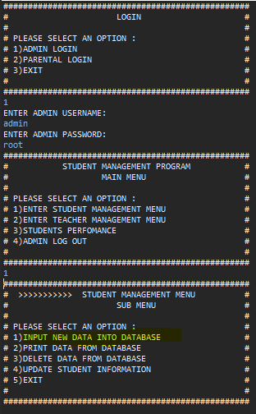
Fig 2.1 Students Management system Console application
(1)Add operation:
When admin is logged in, he/she can enter into the students/teachers management sub menu, they can select an option that says “INPUT NEW DATA INTO THE DATABASE”,
It will allow them to insert data relevant, and it will simultaneously update the database.
(2)Delete operation:
Same as above, the admin can also delete an entire tuple and the data will be deleted in the database. They can select an option that says “DELETE DATA FROM DATABASE”,
(3)Query operation:
Admin can also view the entire data that is available in the database .they can select an option that says “PRINT DATA FROM DATABASE”,
(4)Update operation:
Admin can update a particular attribute provided it is declared as “null “in the database. They can select an option that says “UPDATE ………..INFORMATION”.
(5)View statistics:
Admin and parents have access to the student’s academic report. They can select an option that says “STUDENTS PERFOMANCE” in the student management menu via admin access or through the option “PARENTAL LOGIN”,

3 Conceptual design stage
The Student Management System has a Students Entity, Teachers Entity, Major Entity and the like.

3.1 Student_info entity E-R diagram
The Students_info entity has attributes such as SID (Student Identification), Fname, Lname, MID (Major identification), Year, Gender, Email, Nationality, and its E-R diagram is shown in Figure 3.1.
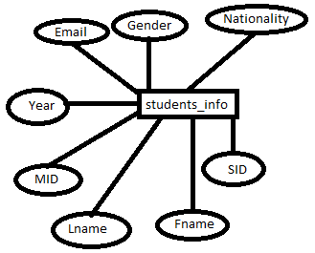
Figure 3.1. Students_info entity E-R diagram

3.2 Major_info entity E-R diagram
The Major_info entity has attributes such as Major_name, MID (Major identification), and its E-R diagram is shown in Figure 3.2.
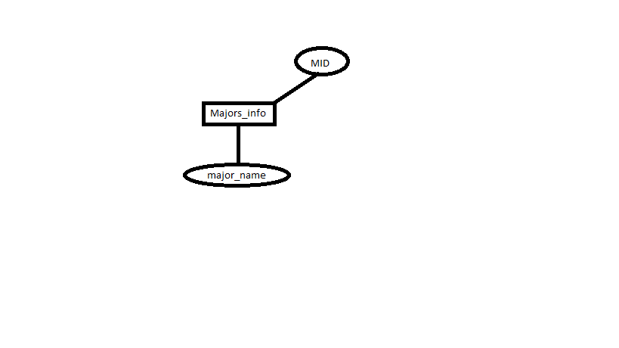
Figure 3.2. Major entity E-R diagram

3.3 Teacher_info entity E-R diagram
The Teacher entity has attributes such as, TID (Teacher Identification) teacher_name, MID (Major identification)... and its E-R diagram is shown in Figure 3.3.
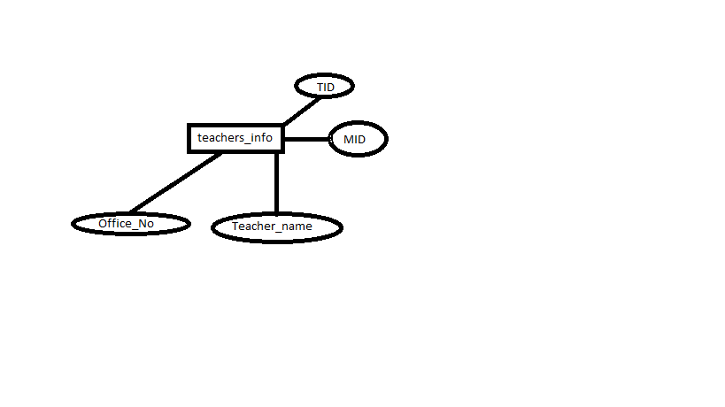
Figure 3.3. Teacher entity E-R diagram

3.4 Course_info entity E-R diagram
The Course_info entity has attributes such as, MID, CID, Course_name, and its E-R diagram is shown in Figure3.4.
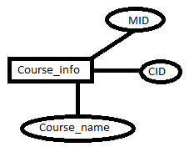
Figure 3.4 Course_info ER diagram

3.5 grade_info entity E-R diagram
The grade_info entity has attributes such as, SID, CID, Scores, and its E-R diagram is shown in Figure3.5.
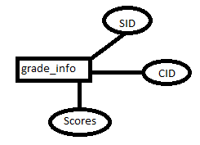
Figure 3.5 grade_info ER diagram

3.6 relatives_info entity E-R diagram
The relatives_info entity has attributes such as, SID, CID, Scores,
and its E-R diagram is shown in Figure3.6.
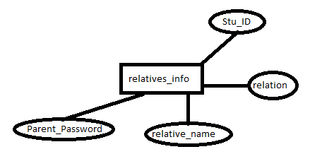
Figure 3.6 relatives_info ER diagram

3.7 Total Student Management System E-R diagram
The total E-R diagram (some entity attributes are removed on purpose) is shown in figure 3.7.
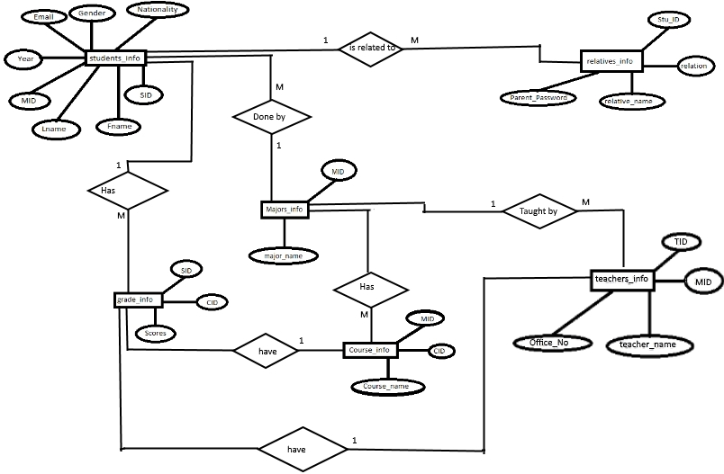
Figure 3.7 total E-R diagram

4 Logical structure design stage

4.1 E-R diagram is converted to relational model
According to the above E-R diagram, we can convert to the following relational model:
Students_info (SID, Fname, Lname, MID, Year, Email, Phone, Gender, Nationality)
Major_info (MID, Major_name)
Teachers_info (TID, Teacher_name, MID)

4.2 Data Dictionary
Based on the results of the conceptual design phase, we can list its data dictionary for each relationship model, as shown in Tables 4-1 through 4-6.

Table 4-1 Students_info information table
SID | Int(9) | Not null
Fname | varchar(30) | Not null
Lname | varchar(30) | Not null
MID | Varchar(20) | Not null
Year | Int(2) | Not null
Email | Varchar(25) | Not null
Phone | Varchar(15) | null
Gender | Char(1) | Not null
Nationality | Varchar(30) | Not null

Table 4-2 Majors_info Information Table
Data item | Data type and length | Is null
MID | varchar(20) | Not null
Major_name | Varchar(20) | Not null

Table 4-3 Teachers_info Information Table
Data item | Data type and length | Is null
TID | Int(0) | Not null
Teacher_name | Varchar(50) | Not null
Office_No | Varchar(10) | Not null

Table 4-4 Course_info information table
Data item | Data type and length | Is null
MID | Varchar(20) | Not null
CID | Int(10) | Not null
Course_name | Varchar(20) | Not null
Semester | Int (1) | Not null
C_year | Int (1) | Not null

Table 4-5 admin_info Information Table
Data item | Data type and length | Is null
Username | varchar(15) | Not null
Password | Varchar(10) | Not null

Table 4-6 relatives_info Information Table
Data item | Data type and length | Is null
Parent_password | varchar(20) | Not null
Stu_ID | Varchar(20) | Not null
relation | Int (9) | Not null
Relative_name | Varchar (50) | Not null

Table 4-7 grade_info Information Table
Data item | Data type and length | Is null
SID | Int (9) | Not null
CID | Varchar15) | Not null
Scores | Int(5) | null

5 Physical structure design stage

5.1 Objectives and tasks of the physical design phase
The physical design of the database is the process of selecting the physical structure required for the most appropriate application for the logical data model.
Two major tasks are to be completed in this phase:
(1) Determine the physical structure of the database, which is mainly the access method and storage structure in the relational database;
(2) Evaluate the physical structure, with emphasis on time and space efficiency.

5.2 Data storage aspects
The indexes established for each basic table in the database are as follows:

(1)Admin Design table
Figure 5.1 shows the Admin design table.
Figure 5.1 Admin design table

(2)Course_info Design table
Figure 5.2 shows the Course_info Design table.
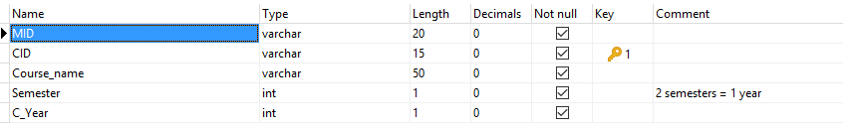
Figure 5.2 Course_info Desgn table

(3)Grade_info Design table
Figure 5.3 shows the Grade_info Design table.
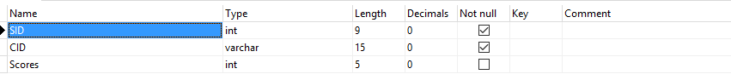
Figure 5.3 Grade_info Design table

(4)Majors_info Design table
Figure 5.4 shows the Majors_info Design table.
Figure 5.4 Majors_info Design table

(5)Relatives_info Design table
Figure 5.5 shows the Relatives_info Design table.
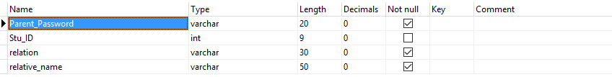
Figure 5.5 Relatives_info Design table

(6)Students_info Design table
Figure 5.6 shows the Students_info Design table.
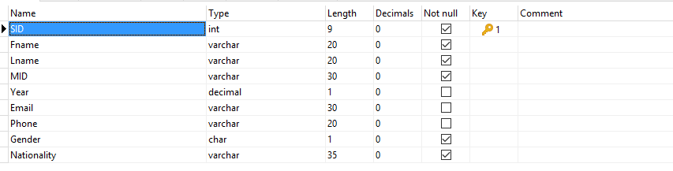
Figure 5.6 Students_info Design table

(7)Teachers_info Design table
Figure 5.7 shows the Teachers_info Design table.
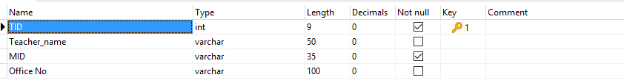
Figure 5.7 Teachers_info Design table

6 Database implementation and maintenance

6.1 Creating database and data tables

6.1.1 Create student_management Database
The SQL for creating the “student_management” database is as follows:

Create database student_management

6.1.2 Students_info table
The SQL for creating the “students_info” database is as follows:
Create table students
(
SID int primary key,
Fname varchar (20) not null
Lname varchar (20) not null
MID varchar (30) not null
Year decimal (1) null
Email varchar (30) null
Phone varchar (20) null
Gender char (1) not null
Nationality varchar (35) not null
)

6.1.3 Create majors_info table
The SQL for creating the “majors_info” database is as follows:
Create table majors_info
(
MID varchar (30) not null,
Major_name varchar (30) null
)

6.1.4 Create teachers_info table
The SQL for creating the “teachers_info” database is as follows:

Create table teachers_info
(
TID int (9) not null,
Teacher_name varchar (50) null,
MID varchar (35) not null,
Address varchar (100) null

)

6.1.5 Create Relatives_info
The SQL for creating the “Relatives_info” database is as follows:

Create table Relatives_info
(
Father Varchar (20) null,
Mother Varchar (20) null,
Guardian varchar (20) null,
Stu_Fname varchar (20) not null,
Stu_Lname varchar (20) not null,
Password varchar (6) not null
)

6.1.6 Create Admin_info
The SQL for creating the “scores_info” database is as follows:

Create table Admin_info
(
Username varchar (15) not null,
Password varchar (10) not null

)

6.1.8 Database diagram
The relationship between the database and the table generated according to the above SQL statement is shown in Figure 6.1.

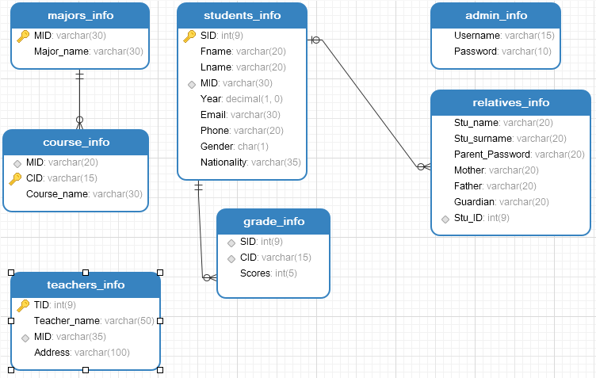

Figure 6.1. Database diagram

6.2 Create views

6.2.1 Create student_country_View
The SQL for the view used to query the basic information of a student’s nationality is defined as follows:
Create view students_country as
Select students_info.Nationality, students_info.Fname
From students_info

6.2.2 Create students_major_View
The SQL for the view used to query the basic information of a student’s current major that he/she is studying for, and is defined as follows:
Create view students_Major_view as
Select students_info.Fname, majors_info.Major_name
From students_info, majors_info
Where students_info.MID = majors_info.MID

6.2.3 Create student_Grade_view
The view used to display ONE student’s grade information, it is defined as follows:
Create view student_Grade_view as
Select students_info.Fname,majors_info.Major_name,course_info.Course_name,grade_info.Scores
From students_info, majors_info, course_info, grade_info
Where students_info.MID = majors_info.MID and
course_info.MID = majors_info.MID and
grade_info.CID = course_info.CID and
/*change SID number to corresponding student */
students_info.SID = '101'

6.2.4 Create teacher_Major_View
This view is used to get information about the teachers and what major they teach, it is defined as follows:
Create view teacher_Major_view as
Select teachers_info.Teacher_name,majors_info.Major_name
From teachers_info,majors_info
Where teachers_info.MID = majors_info.MID

6.2.5 Create student_parent_View
The view used to query the students and relatives information, it is defined as follows:
Create view student_parent_view as
Select DISTINCT
students_info.Fname,students_info.Lname,relatives_info.relative_name,relatives_info.relation
From students_info,relatives_info

6.3 Initialization of data tables

6.3.1 Initialization of the students_info table
The SQL for the Initialization of the students_info table is as follows:

INSERT INTO `students_info` VALUES (101, 'Joakim', 'Munyanyi', 'CS50', 2, 'jockachina@gmail.com', '15638208297', 'M', 'Zimbabwe');
INSERT INTO `students_info` VALUES (102, 'Pavese', 'Nguela', 'ME49', 2, 'pavesenguela@gmail.com', '123456789', 'M', 'Cameroon');
INSERT INTO `students_info` VALUES (103, 'Claire', 'Wagoneka', 'PH48', 2, 'Clairewagoneka@gmail.com', '18638245778', 'F', 'Zimbabwe');
INSERT INTO `students_info` VALUES (104, 'Andrew', 'Chileshe', 'CE47', 2, 'Chileshe@yahoo.com', NULL, 'M', 'Zambia');
INSERT INTO `students_info` VALUES (105, 'Ishmael', 'Mandigo', 'CE47', 1, 'Ishmael@gmail.com', '15693408457', 'M', 'Zimbabwe');
INSERT INTO `students_info` VALUES (106, 'Shadreck', 'Zulu', 'CE47', 2, 'shallyportangel@gmail.com', '13223033462', 'M', 'Zambia');
INSERT INTO `students_info` VALUES (107, 'Nizasono', 'Msimuko', 'CE47', 2, 'nixx@gmail.com', '13223024937', 'M', 'Zambia');
INSERT INTO `students_info` VALUES (108, 'Abihudi', 'Audux', 'EE46', 2, 'abihudi@gmail.com', '18624927106', 'M', 'Tanzania');
INSERT INTO `students_info` VALUES (109, 'Greggory', 'Kiliba', 'CE47', 2, 'mangregg@gmail.com', NULL, 'M', 'Tanzania');

6.3.2 Initialization of the course_info table
The SQL for the Initialization of the course_info table is as follows:
INSERT INTO `course_info` VALUES ('CS50', '1011', 'Intro to Computers', 1, 2);
INSERT INTO `course_info` VALUES ('CS50', '1012', 'C', 1, 2);
INSERT INTO `course_info` VALUES ('CS50', '1013', 'C++', 2, 2);
INSERT INTO `course_info` VALUES ('CS50', '1014', 'Java', 2, 2);
INSERT INTO `course_info` VALUES ('CS50', '1015', 'SQL Databases', 2, 2);
INSERT INTO `course_info` VALUES ('CS50', '1016', 'Data Structs & Algorithms', 2, 2);
INSERT INTO `course_info` VALUES ('CS50', '1017', 'Digital Logic', 2, 2);
INSERT INTO `course_info` VALUES ('CS50', '1018', 'Python', 2, 2);
INSERT INTO `course_info` VALUES ('CS50', '1019', 'linux', 1, 3);
INSERT INTO `course_info` VALUES ('CS50', '1020', 'Computer Composition Principle', 1, 3);
INSERT INTO `course_info` VALUES ('CS50', '1021', '3D Max', 1, 3);
INSERT INTO `course_info` VALUES ('CS50', '1022', 'Operating Systems', 1, 3);
INSERT INTO `course_info` VALUES ('CS50', '1023', 'Computer Network principles', 1, 3);
INSERT INTO `course_info` VALUES ('CS50', '1024', 'Web page Design (HTML)', 1, 3);
INSERT INTO `course_info` VALUES ('CS50', '1025', 'Web Systems and technology', 1, 3);
INSERT INTO `course_info` VALUES ('CS50', '1026', 'E-commerce', 1, 3);
INSERT INTO `course_info` VALUES ('CS50 ', '1027', 'Computer network course design ', 1, 3);
INSERT INTO `course_info` VALUES ('CS50', '1028', 'Web system and tech course design', 1, 3);
INSERT INTO `course_info` VALUES ('PH48', '3001', 'Inorganic Chemistry', 1, 2);
INSERT INTO `course_info` VALUES ('PH48', '3002', 'Human Anatomy', 1, 2);
INSERT INTO `course_info` VALUES ('PH48', '3003', 'Pathophysiology', 2, 2);
INSERT INTO `course_info` VALUES ('PH48', '3004', 'Organic Chemistry', 2, 2);
INSERT INTO `course_info` VALUES ('PH48', '3005', 'Bio Chemistry', 2, 2);
INSERT INTO `course_info` VALUES ('PH48', '3006', 'Traditional Chinese Pharmacology', 2, 2);
INSERT INTO `course_info` VALUES ('CE47', '4011', 'Theoretical Mechanics', 2, 2);
INSERT INTO `course_info` VALUES ('CE47', '4012', 'Building Construction', 2, 2);
INSERT INTO `course_info` VALUES ('CE47', '4013', 'Engineering Materials', 2, 2);
INSERT INTO `course_info` VALUES ('CE47', '4014', 'Auto CAD', 1, 2);
INSERT INTO `course_info` VALUES ('CE47', '4015', 'Engineering Graphics', 0, 0);
INSERT INTO `course_info` VALUES ('CE47', '4016', 'Engineering Surveying', 2, 2);
INSERT INTO `course_info` VALUES ('EE46', '5011', 'Mechanical materials', 2, 2);
INSERT INTO `course_info` VALUES ('EE46', '5012', 'C programming', 2, 2);
INSERT INTO `course_info` VALUES ('EE46', '5013', 'Electronics', 2, 2);
INSERT INTO `course_info` VALUES ('EE46', '5014', 'Engineering Drawing', 1, 2);
INSERT INTO `course_info` VALUES ('EE46', '5015', 'Electronics practicals', 2, 2);

6.3.3 Initialization of the relatives_info table
The SQL for the Initialization of the relatives_info table is as follows:
INSERT INTO `relatives_info` VALUES ('23071993port', 106, 'Father', 'Eugene');
INSERT INTO `relatives_info` VALUES ('1322307tty', 107, 'Mother', 'Mary');
INSERT INTO `relatives_info` VALUES ('aaddxx123', 108, 'Father', 'Audux');
INSERT INTO `relatives_info` VALUES ('joakim0000', 101, 'Father', 'Masimba');
INSERT INTO `relatives_info` VALUES ('joakim0000', 101, 'Mother', 'Joy');

6.3.4 Initialization of the teachers_info table
The SQL for the Initialization of the teachers_info table is as follows:
INSERT INTO `teachers_info` VALUES (461, 'li meng', 'EE46', '');
INSERT INTO `teachers_info` VALUES (471, 'Zheng Kai Xuan', 'CE47', NULL);
INSERT INTO `teachers_info` VALUES (472, 'Ou mang', 'CE47', NULL);
INSERT INTO `teachers_info` VALUES (473, 'Xie XiaoJie', 'CE47', NULL);
INSERT INTO `teachers_info` VALUES (474, 'Luo Lin', 'CE47', NULL);
INSERT INTO `teachers_info` VALUES (481, 'li ren', 'PH48', '');
INSERT INTO `teachers_info` VALUES (491, 'Li Yen', 'ME49', NULL);
INSERT INTO `teachers_info` VALUES (501, 'Ouyang', 'CS50', 'XK 402');
INSERT INTO `teachers_info` VALUES (502, 'Sun Bing', 'CS50', '');
INSERT INTO `teachers_info` VALUES (503, 'Li jing jing', 'CS50', '');
INSERT INTO `teachers_info` VALUES (504, 'Mao jian jing', 'CS50', '');
INSERT INTO `teachers_info` VALUES (505, 'TanTongDe', 'CS50', '');
INSERT INTO `teachers_info` VALUES (506, 'Feng Nai Qin', 'CS50', NULL);
INSERT INTO `teachers_info` VALUES (507, 'Feng Meng Qing', 'CS50', NULL);
INSERT INTO `teachers_info` VALUES (508, 'Yao Yin le', 'CS50', NULL);

6.3.5 Initialization of the majors_info table
The SQL for the Initialization of the majors_info table is as follows:
INSERT INTO `majors_info` VALUES ('CE47', 'Civil Engineering');
INSERT INTO `majors_info` VALUES ('CS50', 'Computer Science');
INSERT INTO `majors_info` VALUES ('EE46', 'Electrical Engineering');
INSERT INTO `majors_info` VALUES ('ME49', 'Mechatronics');
INSERT INTO `majors_info` VALUES ('PH48', 'Pharmacy');

6.3.6 Initialization of the grade_info table
The SQL for the Initialization of the grade_info table is as follows:
INSERT INTO `grade_info` VALUES (101, '1011', 98);
INSERT INTO `grade_info` VALUES (101, '1012', 90);
INSERT INTO `grade_info` VALUES (101, '1013', 100);
INSERT INTO `grade_info` VALUES (101, '1014', 92);
INSERT INTO `grade_info` VALUES (101, '1015', 0);
INSERT INTO `grade_info` VALUES (101, '1016', 0);
INSERT INTO `grade_info` VALUES (101, '1017', 0);
INSERT INTO `grade_info` VALUES (101, '1018', 0);
INSERT INTO `grade_info` VALUES (106, '4014', 79);
INSERT INTO `grade_info` VALUES (106, '4015', 87);
INSERT INTO `grade_info` VALUES (107, '4014', 78);
INSERT INTO `grade_info` VALUES (107, '4015', 86);
INSERT INTO `grade_info` VALUES (108, '5011', 100);
INSERT INTO `grade_info` VALUES (108, '5014', 94);
INSERT INTO `grade_info` VALUES (101, '1019', 0);
INSERT INTO `grade_info` VALUES (101, '1020', 0);
INSERT INTO `grade_info` VALUES (101, '1021', 0);
INSERT INTO `grade_info` VALUES (101, '1022', 0);
INSERT INTO `grade_info` VALUES (101, '1023', 0);
INSERT INTO `grade_info` VALUES (101, '1024', 0);
INSERT INTO `grade_info` VALUES (101, '1025', 0);
INSERT INTO `grade_info` VALUES (101, '1026', 0);
INSERT INTO `grade_info` VALUES (101, '1027', 0);
INSERT INTO `grade_info` VALUES (101, '1028', 0);

6.3.7 Initialization of the admin_info table
The SQL for the Initialization of the admin_info table is as follows:
INSERT INTO `admin_info` VALUES ('admin', 'root');

6.4 The SQL of query

6.4.1 Query from students_info
We can query the information we need from the students_info. The query statement and query results are shown in Figure 6.2.
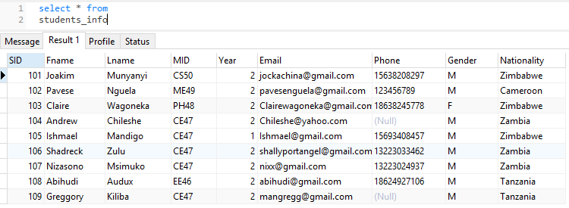
Figure 6.2. Query from students_info table

6.4.2 Query to find number of males and females
We can query the number of Males and Females in students_info. The query statement and query results are shown in Figure 6.3.
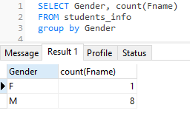
Figure 6.3. Query from course_info

6.4.3 Query from teacher_info and majors_info
We can query the teachers name and what the major he/she teaches from the teacher_info and majors_info .The query statement and query results are shown in Figure 6.4.
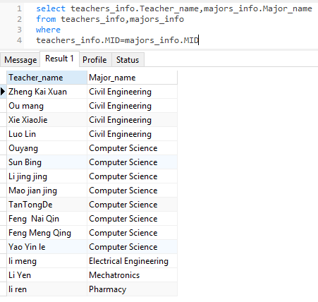
Figure 6.4. Query from teacher_info and majors_info

6.4.4 Query from majors_info and course_info
We can query the major and the courses it provides from the majors_info and course_info. The query statement and query results are shown in Figure 6.5.
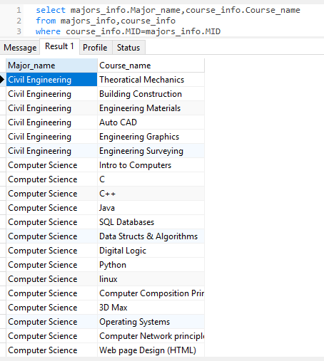
Figure 6.5. Query from majors_info and course_info

7 Experience
(1)From the implementation of this project, I have learnt how to use java to access SQL commands .With this procedure I have managed to create a semi-user friendly interface that allows anyone with no prior experience on how to access, edit, modify, delete data directly for the database, to do so without the need to know the SQL syntax.
(2)Through participating in this project, I have somewhat enriched my knowledge on SQL .SQL is a simple yet somewhat complex language to understand. It is simple in the context that the syntax is rather similar to English language, so even a beginner can pretty much guess what the syntax does .It is complex in the sense that a person needs to familiarize themselves with the way databases are implemented .There are different kinds of databases, however it is important to know which type of database is applicable to a certain topic/subject.

References
[1] www.meeraacademy.com
[2] www.turtorialpoint.com
[3] www.sololearn.com

